

National Academy of Science of Ukraine

NATIONAL ANNUAL REPORT
UKRAINE

The state of biological communities of the Ukrainian sector of ecosystem of the Black Sea in 2023/2024 years

Complied: Dr. Biol. Sc. Galyna Minicheva
Institute of Marine Biology NAS Ukraine

September, 2024

Reporting organizations:

    - Institute of Marine Biology NAS Ukraine (IMB)
- DiverSea project: Integrated observation, mapping, monitoring and prediction for functional biodiversity of coastal seas

Authors of the National Report:

Minicheva H.H. — Corr. Mem., D.Sc. (Biol.), Senior Res. Sci., Bondarenko O.S. — Ph.D. (Biol.), Bohatova Y.I. — Ph.D. (Geogr.), Senior Res. Sci., Bolshakov V.M. — Ph.D. (Geogr.), Senior Res. Sci., Bushuіev S.H. — Ph.D. (Biol.), Harkusha O.P. — Ph.D. (Biol.), Dyatlov S.E. — Ph.D. (Biol.), Assoc. Prof., Kalashnik K.S. — Ph.D. (Biol.), Koshelev O.V. — Ph.D. (Biol.), Kudrenko S.A. — Ph.D. (Biol.), Kulakova I.I. — Ph.D. (Biol.), Senior Res. Sci., Marynets H.V. — Junior Res. Sci., Mihas R.V. — Junior Res. Sci., Martynyuk M.O. — D.Phil., Nikonova S.E. — Junior Res. Sci., Rybalko O.A. — Junior Res. Sci., Synohub I.O. — Senior Res. Sci., Sokolov Ye.V. — Ph.D. (Biol.), Stadnichenko S.V. — Ph.D. (Biol.), Senior Res. Sci., Khutornyі S.O. — Ph.D. (Biol.), Vynogradov O.K. — D.Sc. (Biol.), Prof., Kvach Y.V. — D.Sc. (Biol.), Senior Res. Sci., Demchenko V.O. — D.Sc. (Biol.), Prof., Son M.O. — D.Sc. (Biol.).

CONTENT p.
- Introduction………………………………………………………………. 3
- Consequences of the destruction of the Kakhovka reservoir dam on the Black Sea ecosystem (June - August 2023) ……………………………… 4
- Chronic consequences and response of biological communities to the Kakhovka ecological disaster (January-May 2024) ……………………………………………………………………………15
- Conclusion…………………………………………………………………24
Introduction
Since February 2022, the marine ecosystems of Ukraine, like the whole country, have been affected by the consequences of aggression of the russian federation. The main problem in obtaining information on the state of biological communities is the prohibition of the military to carry out expeditionary work for security reasons. Due to wartime conditions and the impossibility of obtaining field data, the main emphasis is on obtaining satellite information on parameters reflecting the ecological state of the national waters of Ukraine in the Black Sea. Due to extraordinary circumstances - the destruction of the dam of the Kakhovka Reservoir on June 6, 2023 and the release of 14 km² of fresh and polluted water into the Black Sea ecosystem, the Office of the Chief Prosecutor of Ukraine determined the Institute of Marine Biology of the National Academy of Sciences of Ukraine (IMB) as a participant in the investigative action and under the supervision of the military, field work was carried out and empirical material was collected. The impact of the Kakhovka disaster on the Black Sea was divided into two stages: 1 - The shock (hot) phase, which lasted from June to August 2023. 2 - The chronic phase, which continues to last in 2024. In accordance with these circumstances, the CBD National report of RUkraine? presents the results of the study of these two phases and the impact of the consequences of the environmental disaster on the Black Sea ecosystem.

Consequences of the destruction of the Kakhovka reservoir dam on the Black Sea ecosystem (June – August 2023)
"By the end of August 2023, as a result of systematic monitoring of abiotic and biotic indicators, IMB experts recorded the conclusion of the reactions to the 'explosive' (hot) phase of the marine ecosystem in the Ukrainian sector of the northwestern Black Sea. These reactions were in response to the ecological disaster caused by russian aggression. Below are the quantitative characteristics and dynamics of key indicators, which allow us to trace changes in hydrological characteristics, the strength and speed of reactions within biological communities, and the changes in the intensity of ecological processes that occurred following the significant influx of organic and mineral matter into the marine ecosystem from the waters of the Kakhovka Reservoir.
Phytoplankton is a key autotrophic community that is the first to respond to an increase in the concentration of mineral and organic matter in the aquatic environment. Furthermore, the ecological process of phytoplankton blooming is analogous to the burning of organic matter on land. As a result of active phytoplankton blooming, there is a biological "burning" and sedimentation of dissolved nitrogen and phosphorus compounds in the aquatic environment. The dominant groups of planktonic algae, their abundance, the area covered by the bloom, the concentration of chlorophyll "a" in the aquatic environment, and deviations of these indicators from regional norms (anomalies) are key indicators by which it is possible to monitor the speed of assimilation processes in the marine ecosystem, following the unnatural influx of a large volume of allochthonous substances that entered the marine ecosystem as a result of the destruction of the Kakhovka Reservoir dam.
Overall, over the three months of observation, it can be stated that the peak development of cyanobacteria (blue-green algae) in the coastal phytoplankton occurred on June 18, which was two weeks after the explosion of the Kakhovka Dam (Fig. 1). Thus, the abundance of Aphanizomenon flosaquae increased by 2,000 times (regional anomaly +200%), while Jaaginema kisselevii increased by 70 times. The peak values of diatom algae were recorded slightly earlier, on June 11, about a week after the disaster. The abundance of Skeletonema costatum increased by 80 times, and Cylindrotheca closterium by 50 times. Starting from July until August 20, the phytoplankton condition gradually normalized to regional levels and to the values that were present before the influx of water from the Kakhovka Reservoir.
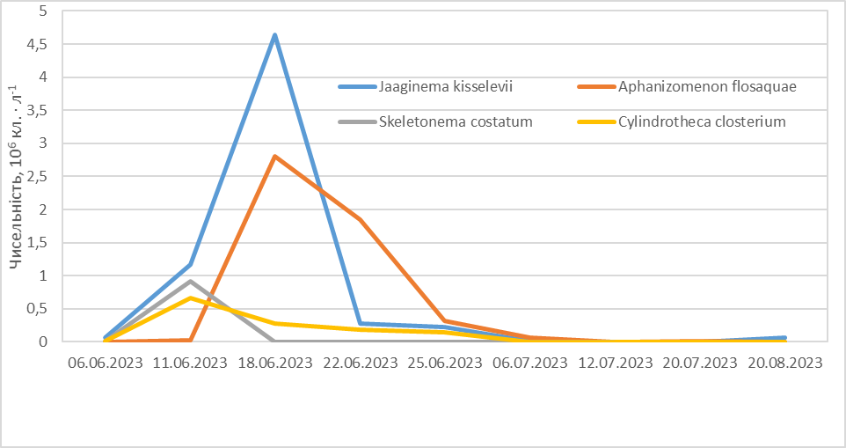

Fig. 1. Dynamics of the abundance of dominant phytoplankton species on the Odesa coastline, in the area of Lanzheron Beach. (Axis Х - dates, Axis Y- Abundance, 10⁶cell /L⁻¹⁾
Satellite data obtained from Sentinel 3 (300m/pixel) and VIIRS-SNPP (formerly MODIS, 1 km/pixel) provided the opportunity to assess the spatial dynamics and immediate trends of blooming dynamics based on chlorophyll-a concentration, which reflects the intensity of blooming and phytoplankton cell density in the marine environment. The overall distribution of bloom hotspots by chlorophyll-a concentration, as well as the total area of the water body affected by the bloom, indicates that by early August it had returned to average regional values (Fig. 2).
June 10, 2023
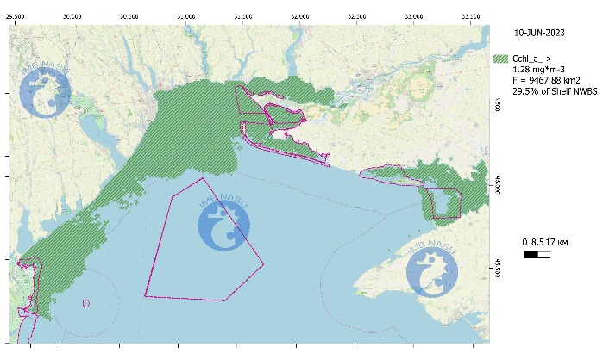 | 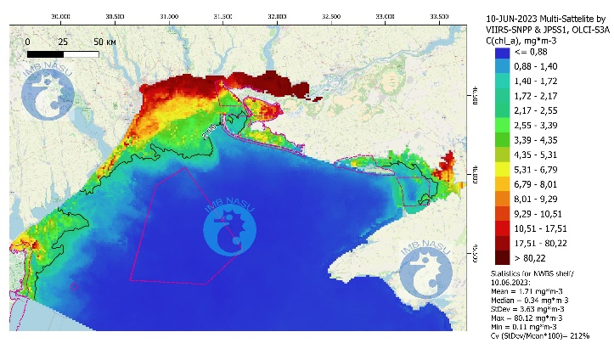
June 15, 2023
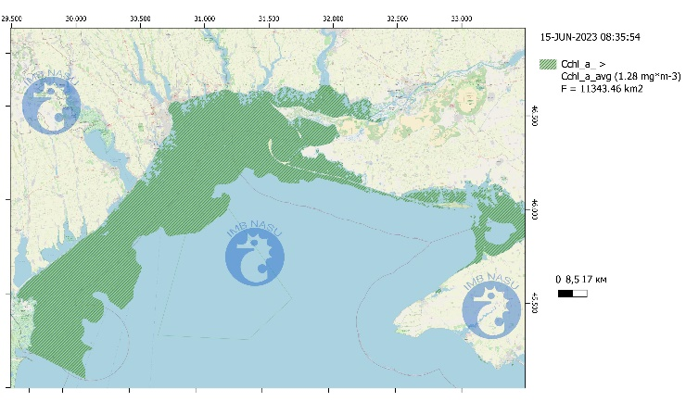 | 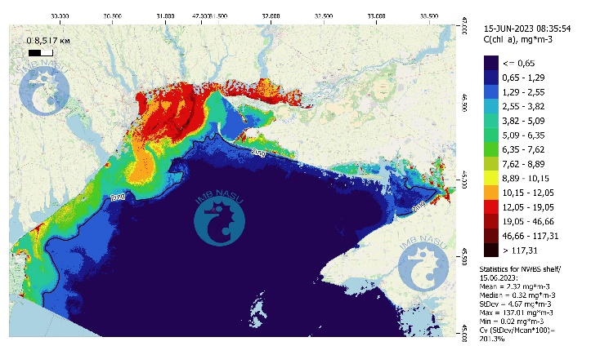
June 27, 2023
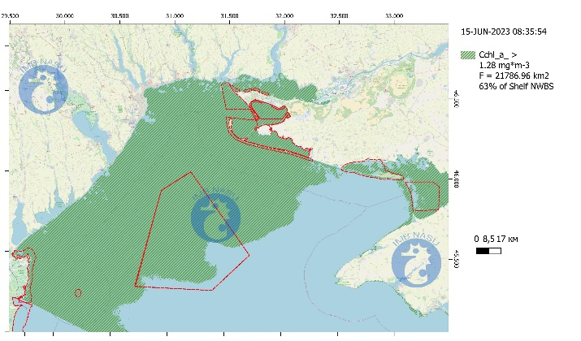 | 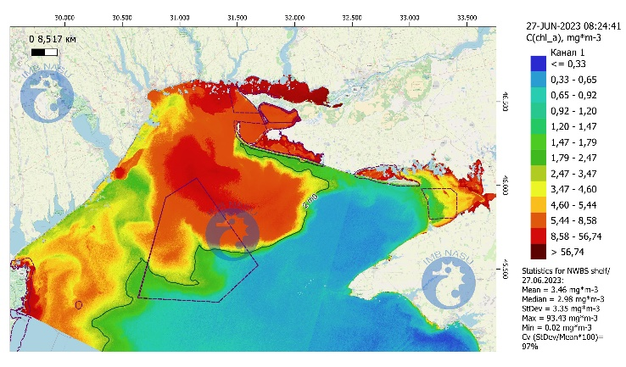
June 30, 2023
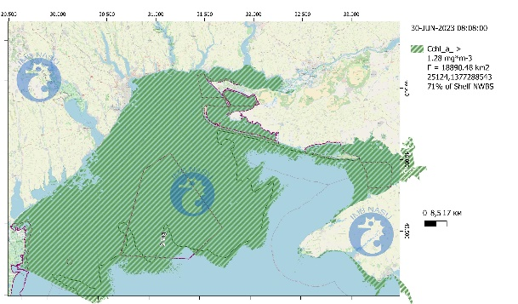 | 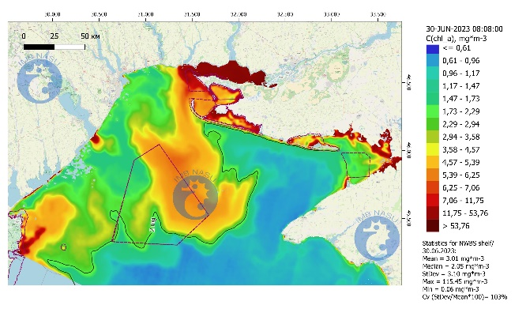
July 5, 2023
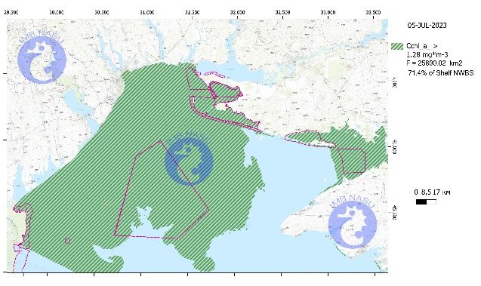 | 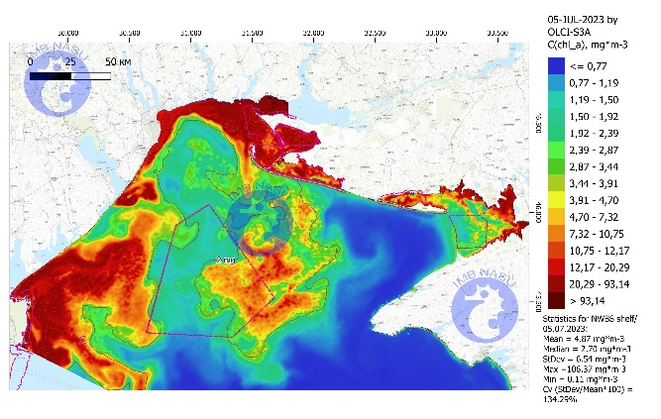
July 15, 2023
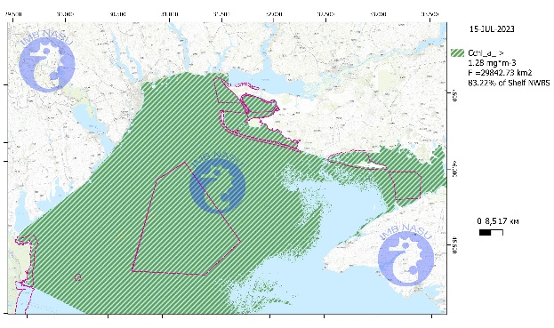 | 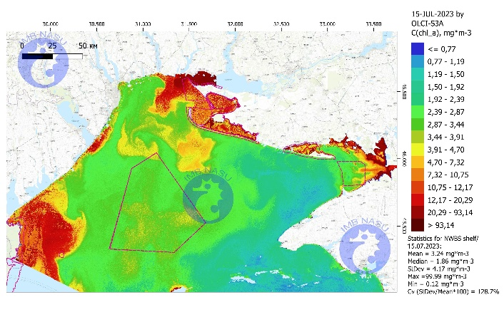
July 25, 2023
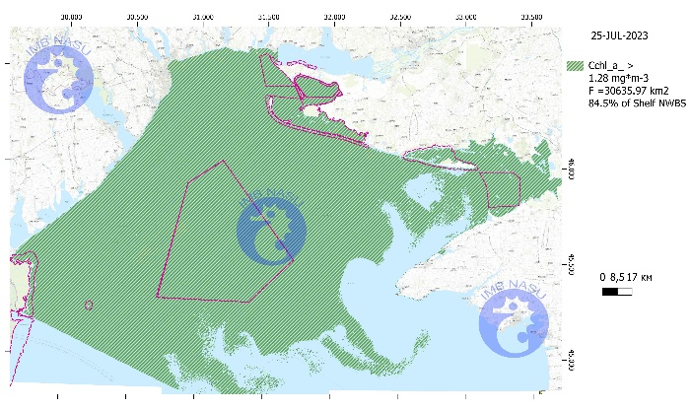 | 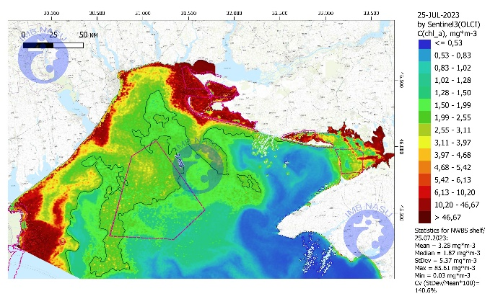
July 29, 2023
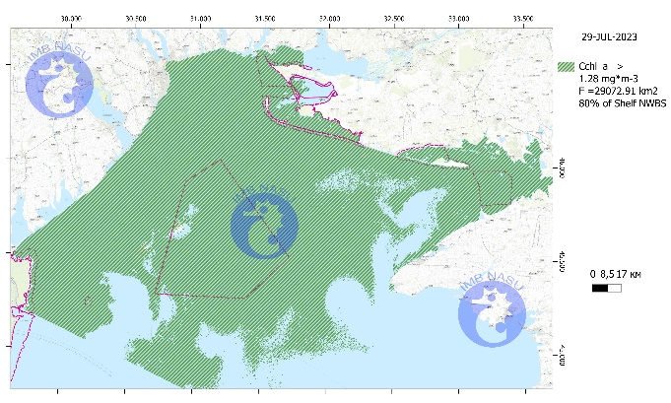 | 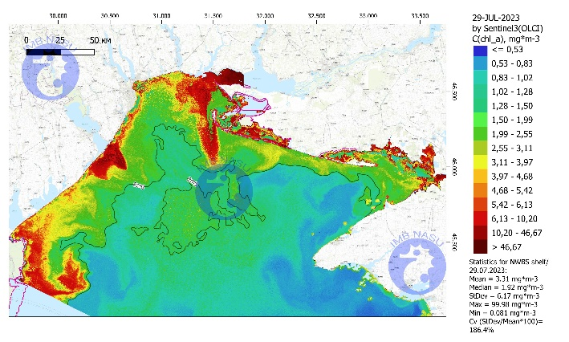
August 5, 2023
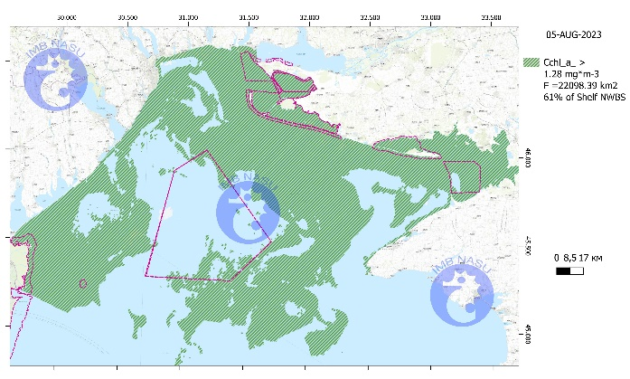 | 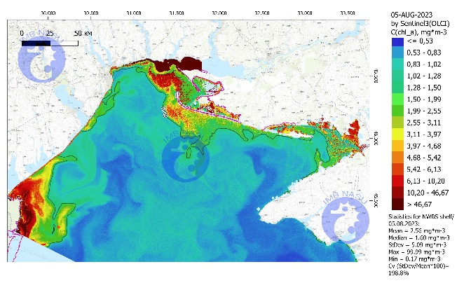
August 24, 2023
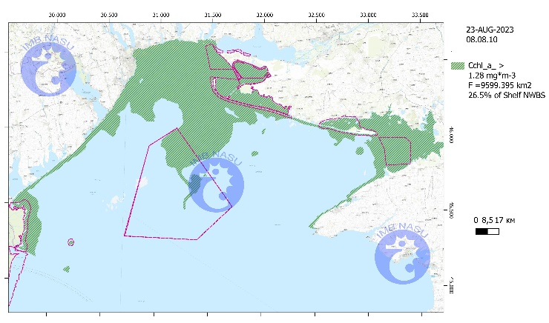 | 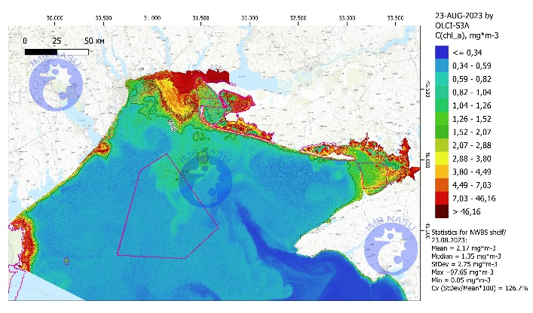

Fig. 2. Dynamics of changes in the total area of blooming and chlorophyll-a concentration in the northwestern Black Sea from June to August 2023 as a result of the destruction of the Kakhovka Reservoir dam.

From mid to late July, the highest percentage of the total area of the Ukrainian sector of the northwestern Black Sea (from Cape Tarkhankut to the Danube delta) occupied by intense phytoplankton blooms was recorded. However, by the end of August, this indicator had returned to the levels observed before the dam's destruction (Fig. 3).

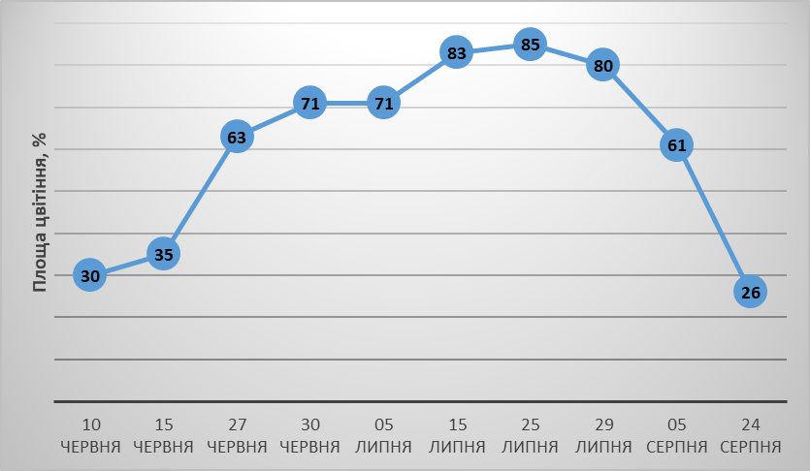

Fig. 3. Dynamics of the percentage of phytoplankton bloom area in the northwestern Black Sea from June to August 2023 as a result of the influx of Kakhovka Reservoir water into the marine ecosystem. ( Axis Х- dates, Axis Y-Blooming area,%)

In average water years, the northwestern part of the Black Sea is characterized by an average chlorophyll-a concentration of 1.28 mg/m³. From this value, the anomaly of chlorophyll-a concentration observed in the month following the disaster at the Kakhovka Reservoir was calculated. By the end of June, the integral spatial anomaly of chlorophyll-a concentration in the northwestern Black Sea reached +170%. The maximum value of +280% was recorded in early July, after which a gradual decrease began (Fig. 4).
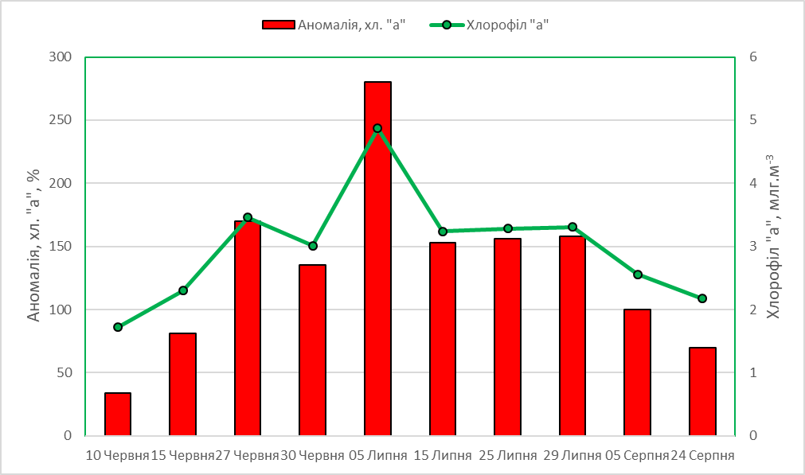
Fig. 4. Dynamics of the average chlorophyll-a concentration values in the northwestern Black Sea from June to August 2023, and the anomalies of increase this indicator relative to regional values for an average water year. (Axis Х- dates, Axis Y: red-Chlorophyll-a anomaly,%; green- Chlorophyll-a, mg/m³)

An important characteristic of phytoplankton blooming intensity, which performs the assimilation function of binding dissolved organic and inorganic substances that have entered the marine ecosystem, is the maximum value of chlorophyll-a concentration. The maximum chlorophyll-a concentration recorded for the northwestern Black Sea in June 2023 was 137.01 mg/m³, which is more than 100 times the regional average level (Fig. 4).
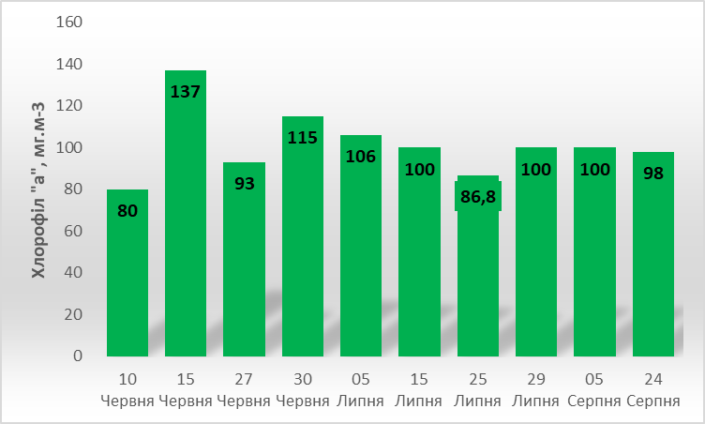

Fig. 4. Dynamics of the maximum chlorophyll-a concentration values recorded in the Ukrainian sector of the northwestern Black Sea from June to August 2023. ( Axis Х- dates, Axis Y- Chlorophyll-a, mg/m³)
A striking indicator of such processes is the parameters of salinity and temperature of the water masses. The warm and fresh water from the Kakhovka Reservoir, which entered the sea 3-4 days after the dam explosion (June 6, 2023), reached the Odesa coastline, and the salinity in the vicinity of Odesa beaches decreased from 14 to 4‰ by June 9 (Fig. 5). All groups of hydrobionts fixed on hard surfaces and in bottom sediments, which cannot move and change their location , were exposed to nearly fresh water for almost a week. Starting from June 18, salinity began to rise due to mixing, and in the last week of June, a very favorable phenomenon for the biological component occurred—a coastal water layer was pushed away from the shore towards the open sea. Cold, salty, and clear deep water moved inshore, increasing the salinity to 18‰ and dropping the water temperature to 12°C. These conditions facilitated the recovery of coastal communities that had previously been affected by a week of freshwater influx. However, this situation changed again on July 5. A change in wind and current direction brought warm, freshened water masses back to the coastal zone (Fig. 5), where an intense bloom of blue-green algae was observed. Another upwelling event occurred on August 6. By the end of August, salinity and temperature levels returned to typical regional values for that seasonal period.

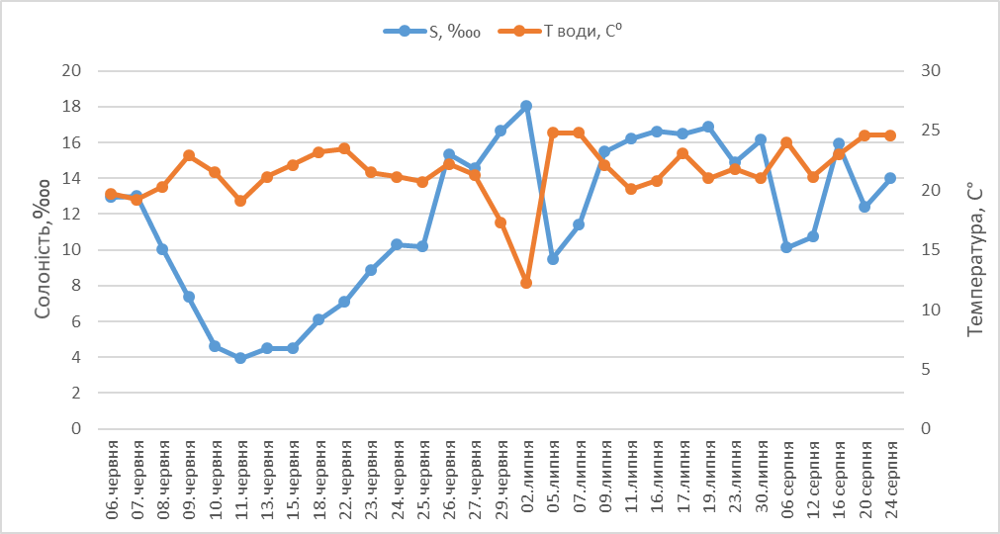

Fig. 5. Dynamics of salinity and sea water temperature at the Odesa coastline from June to August 2023. ( Axis Х- dates, Axis Y: blue- Salinity, ‱; orange- Temperature of water, C⁰)

Although populations of sessile hydrobiota, such as mussels and other mollusks, suffered damage due to being exposed to nearly fresh water (less than 5‰) for about a week, overall hydrological indicators as well as phytoplankton bloom indicators show that by the end of August, the 'explosive' phase of impact on the marine ecosystem had generally ended.
A generalized assessment of abnormal indicators of abiotic factors and various types of hydrobiota communities, recorded during the explosive reaction phase following the destruction of the Kakhovka Reservoir dam, allows us to identify four stages:
I – Hydrological and Hydrochemical Surge Impact – with a focus on significant anomalies in increased river runoff and decreased salinity (June 6-11);
II – Explosive Biological Reaction – with a focus on acute responses of phytoplankton and zooplankton (June 12 - July 10);
III – High Level of Production-Destruction Processes (July 11 - August 10);
IV – Return to Regional Levels (August 11-31).
Chronic consequences and response of biological communities to the Kakhovka ecological disaster (January-May 2024)

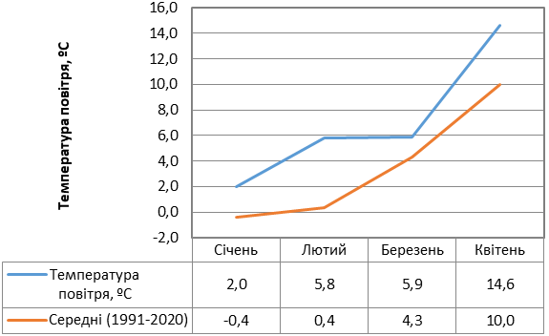
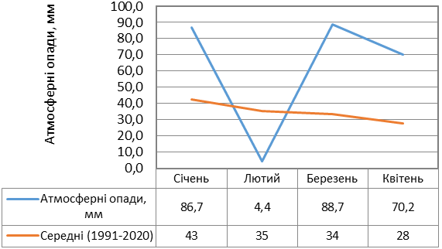
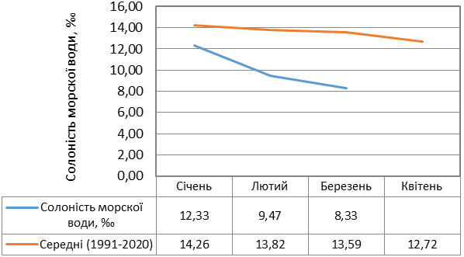
The period from January to May 2024 was marked by significant deviations from the long-term average norms for most meteorological indicators (Fig. 6). During this period, the air temperature exceeded the long-term monthly averages by 1.6 to 4.6 °C. Similar exceedances were characteristic of the average monthly precipitation levels, which in March and April were three times above the monthly norms.
Fig. 6. Dynamics of hydrometeorological indicators in 2024 compared to long-term average data
(A – air temperature,
B – precipitation,
C – seawater salinity).
А
В
С
The salinity of water in marine areas had abnormally low values, ranging between 8-9 ‰, compared to the long-term average of 12-13 ‰. The lowest salinity levels were recorded on March 5, with a value of 5.69 ‰. This is attributed to the relatively high precipitation levels during this period and flooding in the Dnipro, Dniester, and Danube rivers.
Satellite data provided the opportunity to assess the spatial dynamics and temporal trends of phytoplankton blooms based on chlorophyll-a concentration, which reflects the intensity of blooms and phytoplankton density in the marine environment. The research findings revealed low chlorophyll-a levels in January (Fig. 7). In March, there was an intense increase in the concentration of this indicator in the Dnieper-Bug estuary and the coastal areas of Odesa Bay. This was associated with a significant flood and the discharge of biogens from the region’s rivers, as well as relatively high water temperatures. In April and May, mixing processes, dilution, and advection phenomena led to the mixing of seawater and overall contributed to a reduction in the intensity of blooming in the marine waters of the northwestern Black Sea.

January 11 | February 7
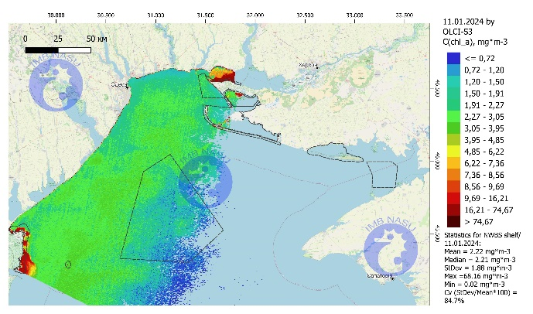 | 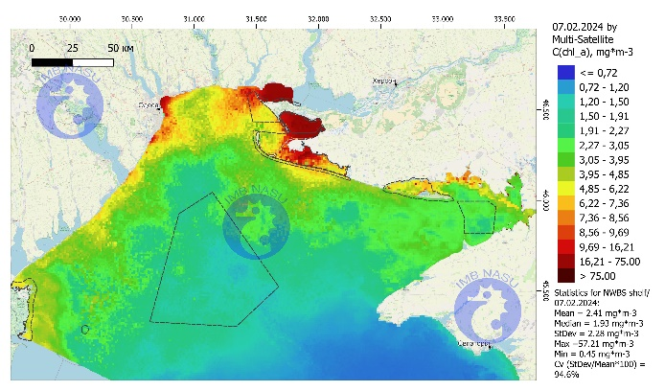
March 9 | March 31
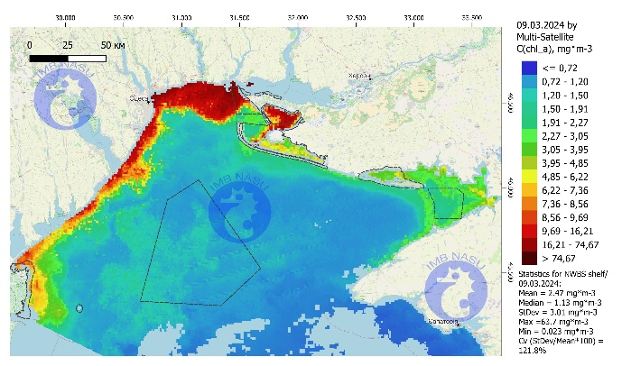 | 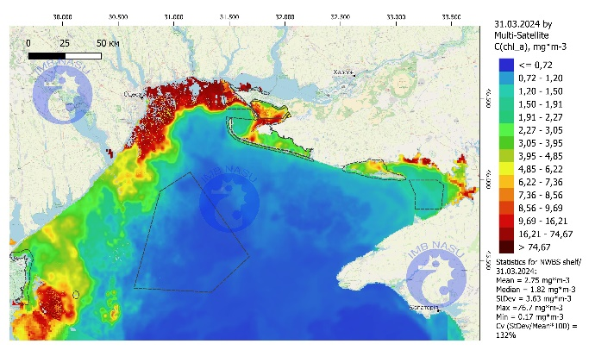
April 8 | May 3
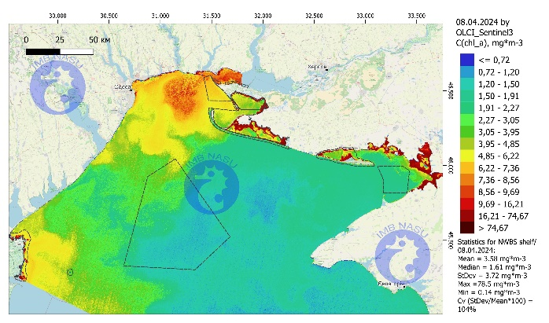 | 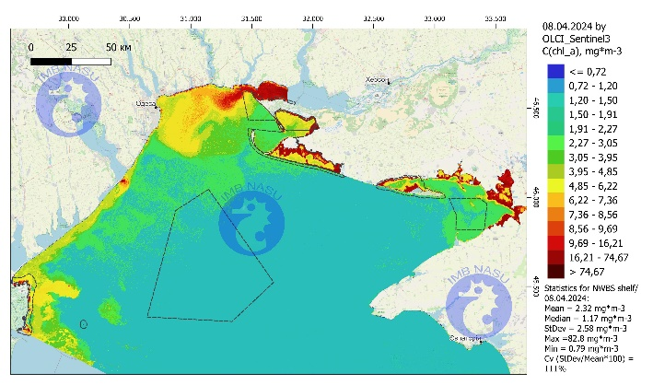

Fig. 7. Distribution of chlorophyll "a" in the waters of the northwestern Black Sea in 2024

In the coastal part of the marine ecosystem, the development of phytoplankton, which is a fundamental autotrophic component and determines the rate of ecological processes, is largely dependent on the amount of allochthonous substances entering the sea from the watershed with precipitation. In the spring of 2023 and 2024, a high dependence of phytoplankton communities on the amount of precipitation was observed (Fig. 8).

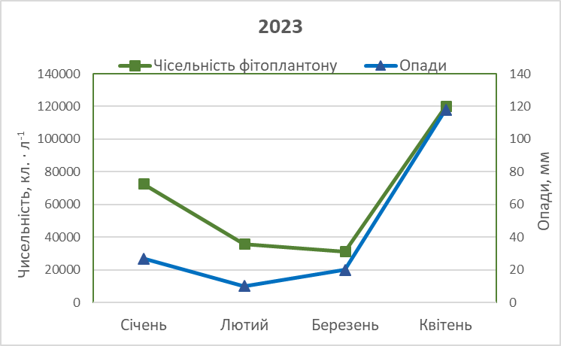А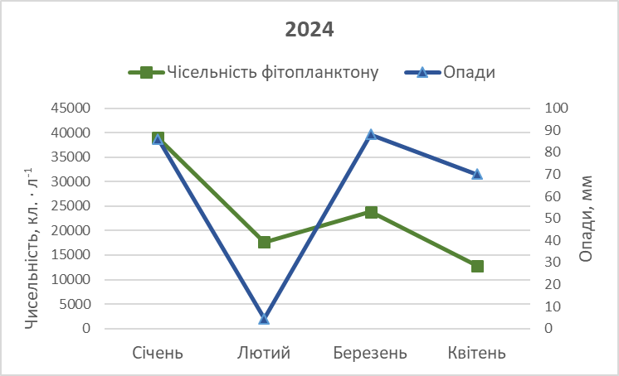В

Fig. 8. Dependence of phytoplankton indicators on precipitation levels in spring 2023 (A) and 2024 (B) in the Odesa coastal region. (Axis Х- dates, Axis Y: green- Phytoplankton density, cell/ L⁻¹; blue - Precipitation, mm)

The decrease in the total volume of precipitation in spring 2024 compared to the corresponding period in 2023 led to a correspondingly lower level of phytoplankton development. For example, the cell density of planktonic algae in the coastal area of Odesa in April 2023 was an order of magnitude higher than in April 2024 (Fig. 9).

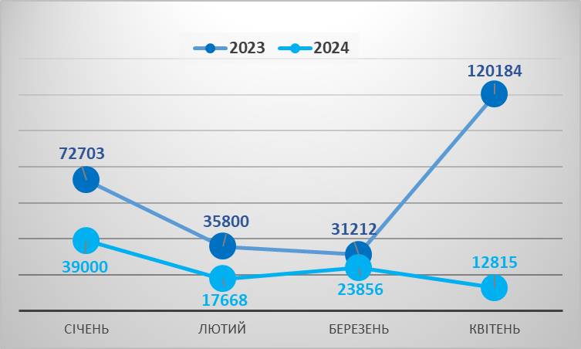

Fig. 9. Comparative characteristics of phytoplankton abundance in the Odesa coastal region in spring 2023 and 2024.

The values of zooplankton biomass in February and spring 2024 were also lower compared to previous years in the corresponding months (especially in March and February). This is likely explained by the recovery of the community after the impact of a large volume of freshwater inflow in June 2023. Overall, the quantitative indicators of zooplankton are showing a trend toward increase and are approaching the levels of previous years.
The contribution of individual zooplankton taxa to the formation of the total biomass of the community in autumn 2023 and spring 2024 did not significantly differ from that observed in previous years for the corresponding months (Fig. 10). In autumn, the zooplankton biomass was primarily composed of Copepoda (species of the genera Acartia and Oithona davisae), the small branchiopod Pleopis polyphaemoides, and Cirripedia larvae. In spring, the dominant role in biomass formation was played by typical representatives of the spring zooplankton of the NW Black Sea, which develop in the first half of biological spring: the ephyras of the jellyfish Aurelia aurita and rotifers of the genus Synchaeta. Due to higher temperatures in March and April 2024, the development of rotifers and meroplankton began earlier than in previous years.

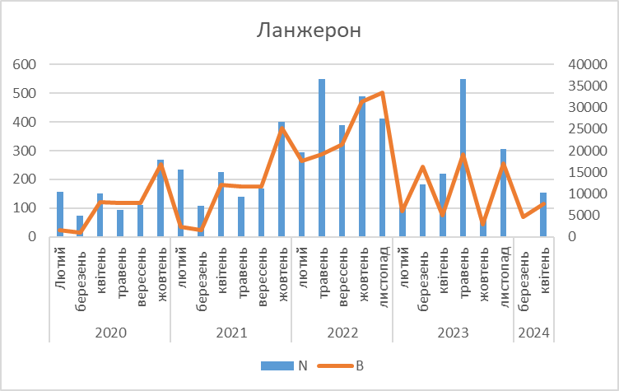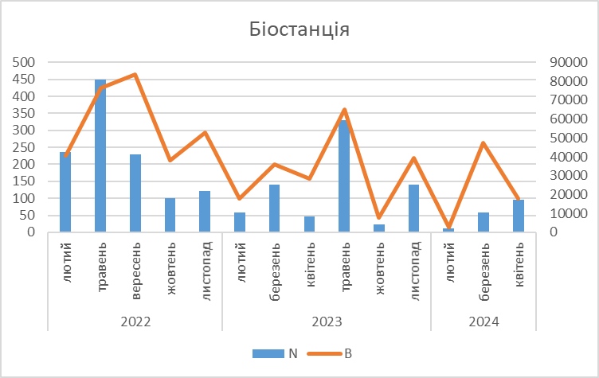
Fig. 10. Abundance (N, ind./m³) and biomass (B, mgm/m³) of zooplankton in the coastal zone of Odesa near Lanzheron Beach and the Hydrobiological Station of ONU in autumn and spring 2020-2024.

After the Kakhovka disaster and until the end of February 2024, an increase in the number of macrozoobenthos taxa in the structure of the community of natural hard substrate overgrowth was observed (Fig. 11).
Fig. 11. Dynamics of macrozoobenthos taxa abundance in the community of epilithic organisms on stones and rocks in the Malyi Fontan area at different depths. (Axis Х- dates, Axis Y- Number of taxa: blue- up to 3 m, red – 4-5 m)

At a depth of 0–3 m—where it was directly affected by desalinated water in June 2023—the biomass of Mytilus galloprovincialis Lamarck, 1819 was restored., The biomass of this mollusk decreased at a depth of 4–5 m from mid-summer 2023 (Fig. 12).

Fig. 12. Dynamics of Mytilus galloprovincialis biomass in the zoobenthos of stones and rocks at different depths in the area of Malyi Fontan. (Axis Х- dates, Axis Y- Biomass, g/ m²: blue- up to 3 m, red – 4-5 m)

One component of the zoobenthos, crustaceans from the order Amphipoda, is a very sensitive indicator of increased levels of organic matter in the ecosystem. While the regional average density of amphipods during spring reproduction is around 10,000 ind./m², the dead organic matter that entered the marine ecosystem from the Kakhovka Reservoir in June 2023 served as the basis for intensive reproduction of small crustaceans in the coastal zone, raising their density to 16,500 ind./m² (Fig. 13). The chronic effects of the influx of organic matter into the marine system can still be observed today. During the spring reproduction of amphipods, the new generation of crustaceans utilized the additional allochthonous material, resulting in an even greater population surge in spring 2024 (see Fig. 13).

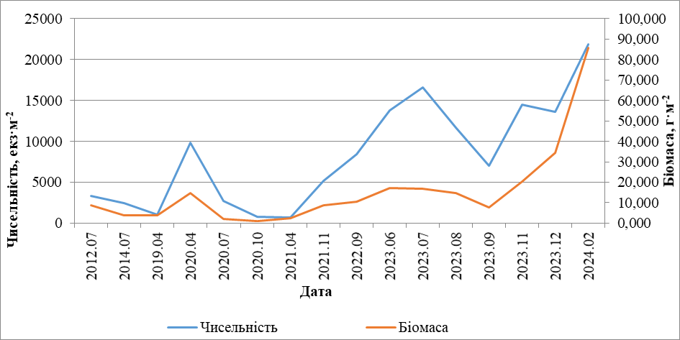

Fig. 13. Dynamics of abundance (ind./m²) and biomass (g/m²) of Amphipoda in the coastal zone of the Odesa Bay of the Black Sea in 2012, 2014, and 2019-2024.
In summary, it should be noted that in conditions of military impact, when various types of anthropogenic influences typical of peacetime are virtually halted, climatic conditions become the primary factor affecting the ecological status of the marine regional ecosystem. Elevated temperatures and river runoff lead to intensified ecological processes and a decrease in the ecological status category, whereas reduced temperatures and lower precipitation and river runoff volumes can improve the ecological status of the marine ecosystem, in the absence of other anthropogenic pressures.
Considering the wartime years, in terms of water temperature, the most favorable year for the ecological status was 2022, with a minimum regional value of 3.7°C. In 2023 and the spring of 2024, the water temperature returned to the regional average level.
Regarding water flow, the wartime years also showed significant differences. The year 2022 was the driest. For example, the annual river discharge of the Danube, which has the greatest impact on the northwestern part of the Black Sea, was 33% below the regional average. In 2023, this value was 38% above the average. The spring of 2024 was characterized by high levels of precipitation, with January receiving twice the monthly norm, and March and April receiving more than two and a half times the norm.
Using the morphofunctional indicator of benthic vegetation – SI (Surface Index of Phytocoenoses) for the coastal zone of the Odesa coastline, the dynamics of changes in the ecological status categories during the pre-war and wartime periods were obtained (Fig. 14). The diagram shows that favorable climatic conditions and the complete cessation of anthropogenic pressures, including recreation, led to a significant improvement in the ecological status of the Odesa coastline compared to the pre-war period. Less favorable marine water temperature conditions and precipitation levels in 2023 and the spring of 2024, as well as the partial resurgence of at least recreational pressures, progressively increased the values of the benthic vegetation indicator, which accordingly affected the category of ecological status (see Fig. 14).

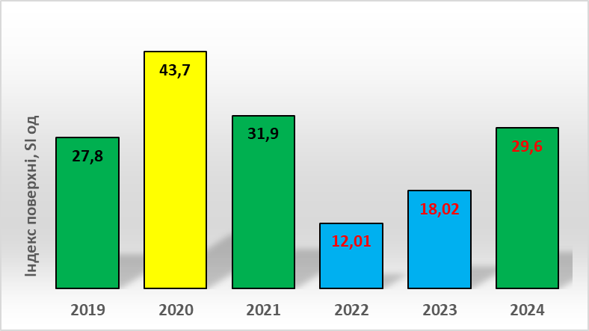

Fig. 14. Interannual dynamics of ecological status class categories (yellow – "Average", green – "Good", blue – "High"), based on benthic vegetation indicator values along the Odesa coastline during the pre-war and wartime periods.
(Axis Х- Annual dinamics, Axis Y- Surface Index, SI)

Invasive species
During the wartime period in the northwestern part of the Black Sea, its estuaries, and major rivers, an increase in biological contamination has also been observed. During 2023-2024, both the introduction of new species to the Black Sea basin, such as the rockfish Sebastes schlegelii and several species of balanus, and the establishment or expansion of populations formed in the previous 1-2 years were observed. These include the mollusks Arcuatula senhousia and Menetus dilatatus, the sea anemone Nematostella vectensis, the prawn Macrobrachium nipponense and Palaemon macrodactylus. The diversity of invasion vectors indicates the influence of both large-scale changes in maritime traffic in the Black Sea and the Lower Danube and the general weakening of controls in areas related to the use of living organisms, such as aquarium keeping, aquaculture, and the trade of live seafood.
Conclusion
- The anomaly in the volume of polluted freshwater that entered the marine ecosystem in the first week after the destruction of the Kakhovka dam amounted to 650% of the average regional level of river discharge from the Dnipro River. Minimum salinity values of 3.95 ‰ were recorded off the Odesa coast on June 11. Salinity at the level of 4.0 ‰ (3 times lower than the minimum permissible limit of TLV 12 ‰) was maintained from June 10 to June 17, corresponding to a 71% anomaly from the regional average. Gradually, due to water mass mixing, salinity increased and by June 26 reached the typical regional level of 15 ‰. In July-August 2023, salinity in the region fluctuated between 10-17 ‰, influenced by summer wind-driven upwelling and downwelling events.

- The main changes in the hydrochemical regime following the inflow of water from the reservoir were the reduction of oxygen saturation in the surface layer of the sea to less than 75% and the increase in nutrient concentrations. High concentrations of ammonium nitrogen — 1.2-2.6 TLV were recorded on the sixth day after the disaster in the area off the Odesa coast, with maximum levels (13.8 TLV) registered on June 9 at Station 1. Additionally, abnormally high concentrations of phosphates and silicic acid were observed, exceeding the long-term average values by 2-3 times, though the maximum phosphate concentrations did not surpass the permissible limit (TLV).

- Observation data obtained from Sentinels satellites indicate that by the end of June, the integrated spatial anomaly of chlorophyll «a» concentration in the northwestern part of the Black Sea reached +170%. The maximum value of +280% was recorded at the beginning of July, followed by a gradual decline, which returned to the regional level by the end of August.

- The peak of the mass development of blue-green planktonic algae, dominated by Aphanizomenon flosaquae and Jaaginema kisselevii, occurred on June 18, 2023. The maximum regional anomaly in phytoplankton abundance was observed between June 11-22, reaching a record level of approximately +1400%

- The most significant changes in the structure of fouling communities occurred in the coastal zone at depths of up to 3 meters. From June 3 to mid-July, mass mortality of mussels (Mytilus galloprovincialis) was recorded at depths of 0-3 meters, reaching up to 1067 dead individuals per 1 m² of hard substrate. At the same time, there was an increase in the number of more stress-tolerant species, such as the mollusk Mytilaster lineatus, whose population exceeded 130,000 individuals per m². Additionally, the ecological conditions led to a rapid increase in the number of small detritivores and plant-detritus-feeding invertebrates, with maximum abundance anomalies exceeding 660% and 1400%, respectively.

- In the marine coastal zone, on natural and artificial hard substrates at depths of up to 3 meters, under the influence of desalinated water, the number of dead M. galloprovincialis individuals reached up to 583 ind./m² ± 115 ind./m², with a biomass of 4090 g/m² ± 974 g/m². According to estimates, the total biomass of the dead portion of the mussel population was approximately 3.7 thousand tons, which accounts for about 40% of the natural coastal population of this mollusk in the northwestern part of the Black Sea.

- A generalized assessment of abnormal indicators of abiotic factors and various types of hydrobiota communities, recorded during the explosive reaction phase following the destruction of the Kakhovka Reservoir dam, allows us to identify four stages:
I – Hydrological and Hydrochemical Surge Impact – with a focus on significant anomalies in increased river runoff and decreased salinity (June 6-11);
II – Explosive Biological Reaction – with a focus on acute responses of phytoplankton and zooplankton (June 12 - July 10);
III – High Level of Production-Destruction Processes (July 11 - August 10);
IV – Return to Regional Levels (August 11-31).
- The Black sea marine ecosystem has done a very important work in the first three months as a large, biological assimilation machine for the consequences of the Kakhovka disaster.

- But as a result, the marine ecosystem has been scars. These scars are chronic consequences. The most dangerous thing is this deposition of pollution from the Kakhovka Reservoir in bottom sediments of the Black Sea. This consequence will have a long-term impact on the life of the marine ecosystem. During strong storms, pollution will again enter the aquatic environment.

- Next year in 2024, a change in the structure-functional organization of biological communities was recorded. Increase in the number of opportunistic organisms and new invaders. Opportunistic organisms are small, short-cycle hydrobionts that are indicators of not good ecological conditions. Invaders can destroy the structure of natural regional communities; this is a real biological pollution.

- Thus, In the Kakhovka tragedy, the Black Sea became a rescuer which that suffered itself. The northwestern part became a buffer zone that protected the rest of the Black Sea. The Kakhovka tragedy became an example of what can happen with uncivilized human behaviour. And russia demonstrated such behaviour to the whole world.

